|  |  |
| --- | --- |
|  | **Airport Management**  **System**  **Technical Design Document**  **1.0** |
| |  |  |  |  | | --- | --- | --- | --- | |  | **Prepared By / Last Updated By** | **Reviewed By** | **Approved By** | | **Name** | Person 1 | Person 2 | Person 3 | | **Role** | Team Member | Team Member | Scrum Master | | **Signature** |  |  |  | | **Date** |  |  |  | |
|  |

Table of Contents

1.0 Introduction 3

1.1 Purpose of this document 3

1.2 Scope 3

1.3 Intended Audience 3

1.4 Definition & Acronyms 3

2.0 Conventions and Standards Followed 4

3.0 Assumptions, Dependencies and Risks 4

3.1 Assumptions: 4

3.2 Dependencies: 4

4.0 Schematic Diagram 4

5.0 Use Case Realization 5

5.1.1 User Registration 5

a. Functional Requirement 6

b. UI Validations 6

c. UI Controls 7

d. UI Methods Definition 8

e. UI Design 9

6.0 Database Design 10

6.1 Data Model 10

6.2 Tables Structure 10

7.0 Change Log 13

# Introduction

## Purpose of this document

The purpose of the detail design document is to define the detailed design for all the components of Airport Management System that are specified in the Business Requirement/Use case document. All the low level components, interfaces and integrations are detailed out in this document.

## Scope

This sub-section shall state the scope of this detailed design document

* Create and maintain plane details
* Create and maintain pilot details
* Create and maintain hangar details and plane allotments

## Intended Audience

*The intended audience for this document are*

* Developers, testers, other associates in the project
* Technical lead, Scrum Master
* Product Owner

## Definition & Acronyms

|  |  |
| --- | --- |
| **Acronyms** | **Definitions** |
| AMS | Airport Management System |

# Conventions and Standards Followed

The modules under scope needs to adhere to the coding standards and guidelines

<https://github.com/diptendusil/JavaCodingStandards>

<https://github.com/diptendusil/SpringMvcStandards>

# Assumptions, Dependencies and Risks

## Assumptions:

* Only one plane can be allotted to one hangar.
* The contact number and alternate contact number are unique throughout the User records.
* Plane scheduling is not present under the project’s functional requirements, so Pilot entity is not yet useful.
* One owner can have only one plane, so the owner is unique throughout the plane records.

## Dependencies:

* Plane has an Owner entry.
* Hangar has a manager(User) entry.

# Schematic Diagram

A schematic, or schematic diagram, is a representation of the elements of a [system](https://en.wikipedia.org/wiki/System) using abstract, graphic [symbols](https://en.wikipedia.org/wiki/Symbol) rather than realistic pictures. It gives an overview of overall system

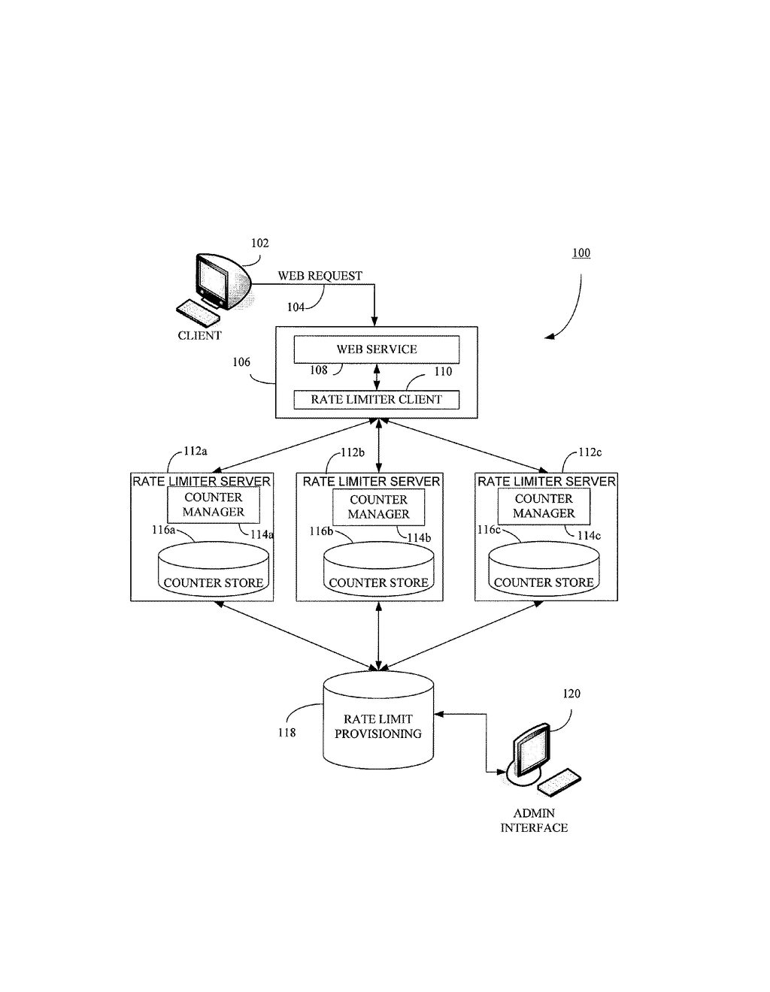

# Use Case Realization

### User Registration

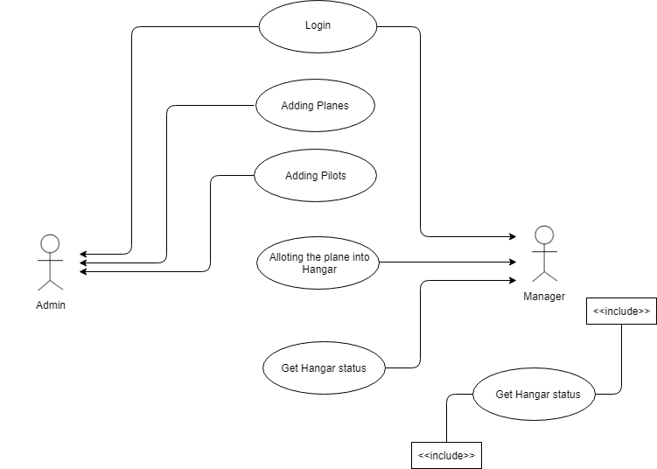

### Functional Requirement

. There are two login pages, one for admin, one for manager. Login Pages checks the authentication of the user and based on his role, directs the user to the respective page. Admin can add, edit and remove planes, pilots and hangar. They can also change the manager in charge of a specific hangar. Manager can view planes, vacant hangars and occupied hangars. Additionally they can allocate plane to the vacant hangars or unallocated plane from occupied hangars. All users can edit their profile. When manager registers, admin has to approve the registration, then only the manager can login.

### UI Validations

* Email Id and Password fields are mandatory.
* Invalid User Id and / or password should not allow the user to get into the system

### UI Controls

|  |  |  |  |  |
| --- | --- | --- | --- | --- |
| **#** | **UI Component** | **Type** | **Name** | **Details** |
| **1** | emailId | Label | emailId |  |
| 2 | emailId | Text field | emailId | To enter Email Id |
| 3 | password | Label | password |  |
| 4 | password | Text field | password | To enter password |

### UI Methods Definition

|  |  |  |
| --- | --- | --- |
| **Method Name** | **Parameter** | **Details** |
| SubmitButton_Click | object sender, EventArgs e | Allows the user to login into the portal and register the patient. |
| BackButton_Click | object sender, EventArgs e | Loads the Homepage after registration is done successfully. |
| HomeButton_Click | object sender, EventArgs e | Loads the Homepage after registration is done successfully. |
| Page_Load | None | None |

### 

### UI Design

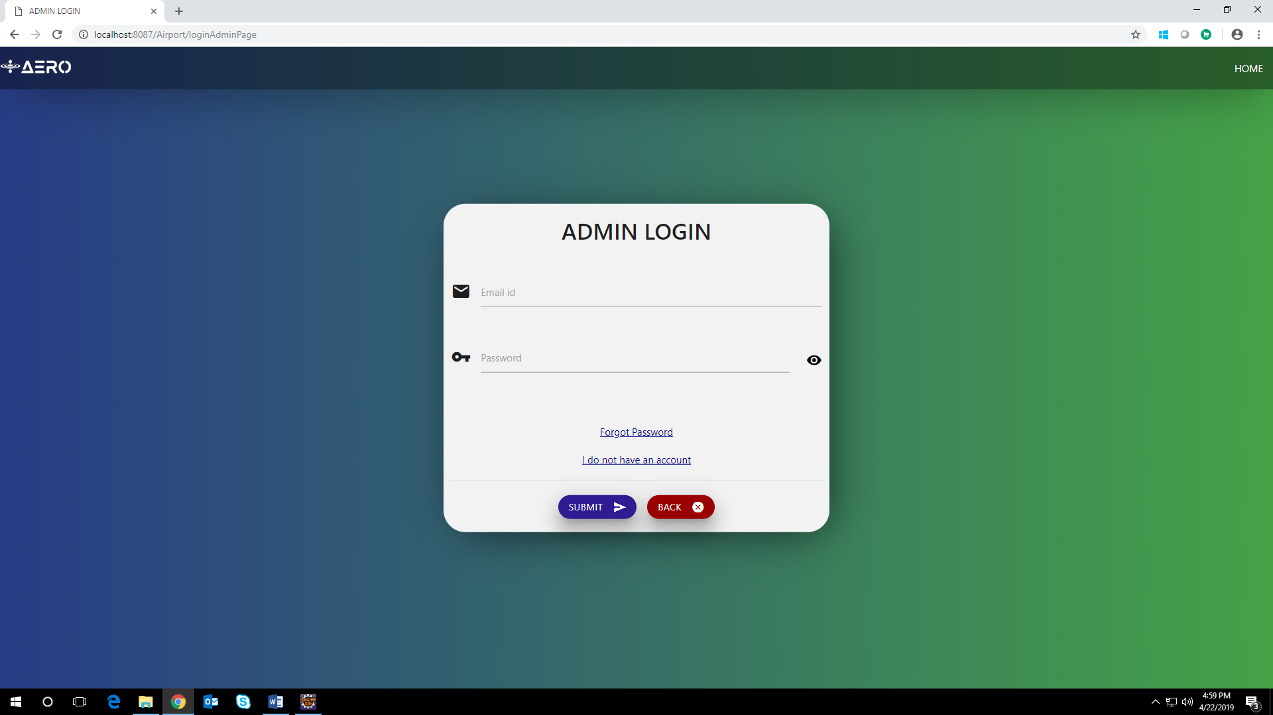

### UI Validations

* All fields are mandatory.
* reCaptcha should should be solved properly before allowing the user to register

### UI Controls

|  |  |  |  |  |
| --- | --- | --- | --- | --- |
| **#** | **UI Component** | **Type** | **Name** | **Details** |
| 1 | firstName | Text field | firstName | To enter First Name |
| 2 | lastName | Text field | lastName | To enter Last Name |
| 3 | age | Number field | age | To enter age |
| 4 | address | Test field | address | To enter address |
| 5 | contactNumber | Number field | contactNumber | To enter contact number |
| 6 | altNumber | Number field | altNumber | To enter alternate contact number |
| 7 | emailId | Text field | emailId | To enter Email Id |
| 8 | password | Password field | password | To enter password |
| 9 | dob | Text field(datepicker) | dob | To enter the date of birth |
| 10 | gender | radio button | gender | To select the gender |

### UI Methods Definition

|  |  |  |
| --- | --- | --- |
| **Method Name** | **Parameter** | **Details** |
| SubmitButton_Click | object sender, EventArgs e | Allows the user to login into the portal and register the user. |
| ClearButton_Click | object sender, EventArgs e | Clears the details entered by the user. |
| HomeButton_Click | object sender, EventArgs e | Loads the Homepage after registration is done successfully. |
| Page_Load | None | None |

1. UI Design

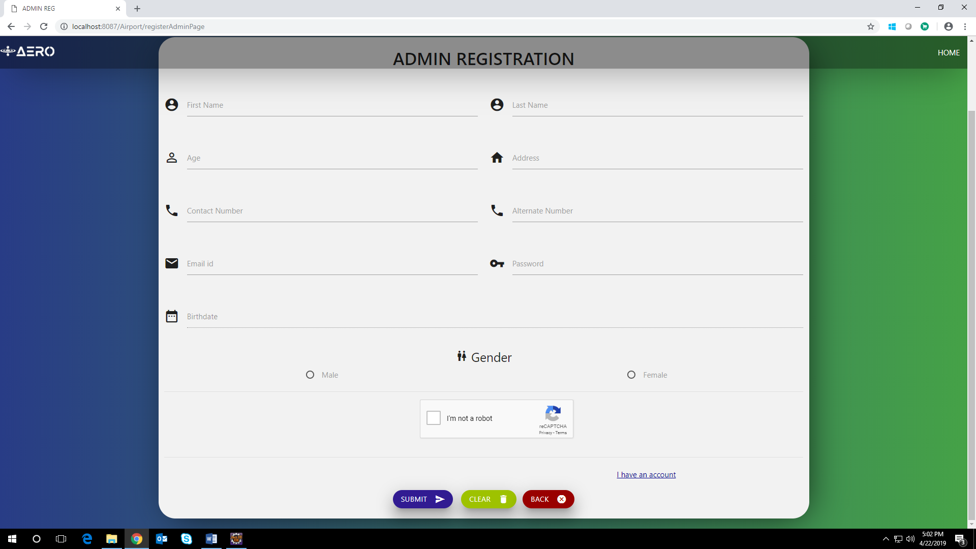

# Database Design

## Data Model

### The following is a schematic view of the database design

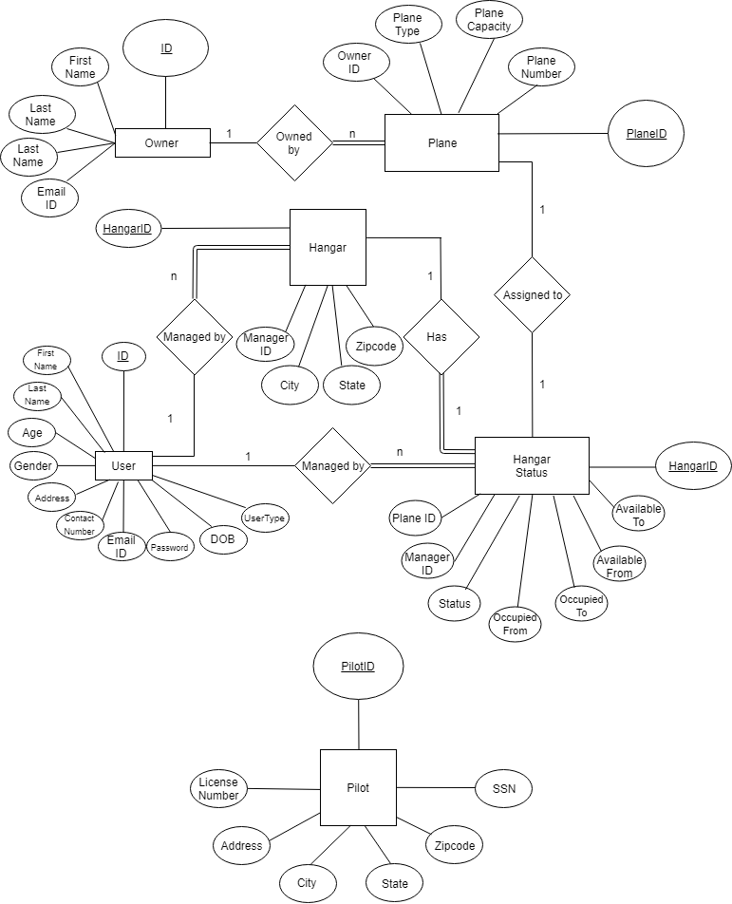

## Tables Structure

**TBL_USER:**

|  |  |  |  |
| --- | --- | --- | --- |
| **Column Name** | **Data Type** | **Length** | **Nulls** |
| ID | NUMBER | 8 | N |
| FIRSTNAME | VARCHAR2 | 50 | N |
| LASTNAME | VARCHAR2 | 50 | N |
| AGE | NUMBER | 2 | N |
| GENDER | VARCHAR2 | 6 | N |
| ADDRESS | VARCHAR2 | 60 | N |
| DOB | VARCHAR2 | 15 | N |
| CONTACTNUMBER | NUMBER | 10 | N |
| ALTNUMBER | NUMBER | 10 | Y |
| EMAILID | VARCHAR2 | 30 | N |
| PASSWORD | VARCHAR2 | 30 | N |
| USERTYPE | VARCHAR2 | 10 | N |
| STATUS | VARCHAR2 | 10 | N |

**TBL_PILOT:**

|  |  |  |  |
| --- | --- | --- | --- |
| **Column Name** | **Data Type** | **Length** | **Nulls** |
| PILOTID | NUMBER | 8 | N |
| LICENSENUMBER | NUMBER | 7 | N |
| ADDRESS | VARCHAR2 | 60 | N |
| CITY | VARCHAR2 | 10 | N |
| STATE | VARCHAR2 | 15 | N |
| ZIPCODE | NUMBER | 6 | N |
| SSN | NUMBER | 9 | N |

**TBL_OWNER:**

|  |  |  |  |
| --- | --- | --- | --- |
| **Column Name** | **Data Type** | **Length** | **Nulls** |
| ID | NUMBER | 8 | N |
| FIRSTNAME | VARCHAR2 | 50 | N |
| LASTNAME | VARCHAR | 50 | N |
| CONTACTNUMBER | NUMBER | 10 | N |
| EMAILID | VARCHAR2 | 30 | N |

**TBL_PLANE:**

|  |  |  |  |
| --- | --- | --- | --- |
| **Column Name** | **Data Type** | **Length** | **Nulls** |
| PLANEID | NUMBER | 8 | N |
| OWNERID | NUMBER | 8 | N |
| PLANETYPE | VARCHAR2 | 10 | N |
| PLANECAPACITY | NUMBER |  | N |
| PLANENUMBER | VARCHAR2 | 7 | N |

**TBL_HANGAR:**

|  |  |  |  |
| --- | --- | --- | --- |
| **Column Name** | **Data Type** | **Length** | **Nulls** |
| HANGARID | NUMBER | 8 | N |
| MANAGERID | NUMBER | 8 | N |
| CITY | VARCHAR2 | 10 | N |
| STATE | VARCHAR2 | 15 | N |
| ZIPCODE | VARCHAR2 | 6 | N |

**TBL_HANGARSTATUS:**

|  |  |  |  |
| --- | --- | --- | --- |
| **Column Name** | **Data Type** | **Length** | **Nulls** |
| HANGARID | NUMBER | 8 | N |
| PLANEID | NUMBER | 8 | Y |
| MANAGERID | NUMBER | 8 | N |
| STATUS | VARCHAR2 | 8 | N |
| OCCUPIEDFROM | VARCHAR2 | 15 | N |
| OCCUPIEDTO | VARCHAR2 | 15 | N |
| AVAILABLEFROM | VARCHAR2 | 15 | N |
| AVAILABLETO | VARCHAR2 | 15 | N |

# Change Log

*Please note that this table needs to be maintained even if a Configuration Management tool is used.*

|  |  |
| --- | --- |
| Version Number | Changes made |
| V1.0 | This is the first version and the final version. It includes the technical and functional details of the application including the table structure |

# 